Thicket of Diversity
700 North St, Suite 79
Beaumont, TX 77701
www.thicketofdiversity.org
Mary C. Johnston, mathicket@aol.com

April 22, 2022
Bees of the Big Thicket National Preserve Phase II: 2022
Daniel J. Bennett1 & John Pascarella2
Addendum
The grant has $2570.15 remaining in unspent funds. The researcher would like to keep the grant open for an additional year through 2023 for the purpose of identifying species collected as bycatch. The ToD Science Committee has approved the expenditure.
Available for additional research include line items for the TWiG Leader ($500)
and for the Undergraduate Student Contractor ($1000).
This increases their allowance to less than the 10% allowable by TCEQ.
For transportation costs the remaining amount open has been reduced to $1070.
This line item cannot be transferred to another category per TCEQ requirements.
TOTAL: $2570
For Addendum:
Required- Turn in data, supporting materials and receipts, and invoice for final payment. A final report is not required.
Best of Luck,
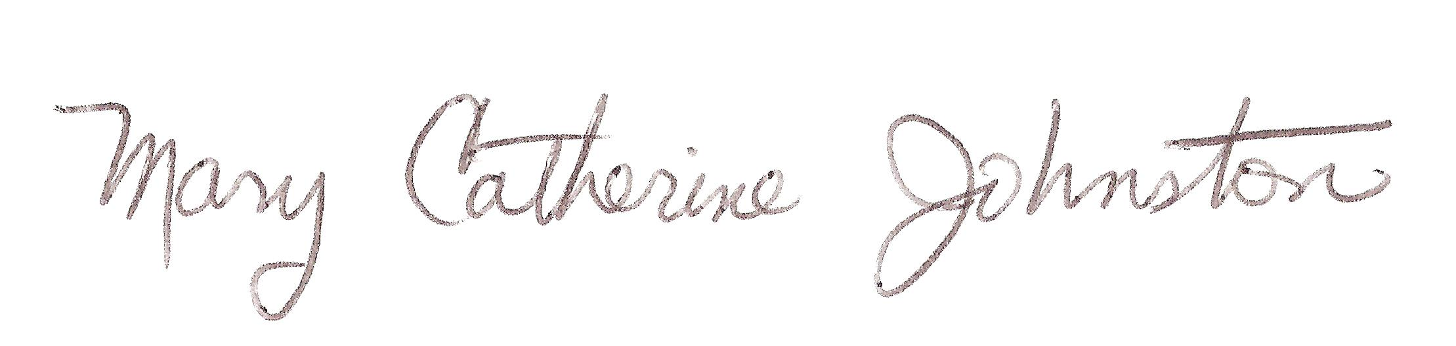
Mary Catherine Johnston,
Chair Thicket of Diversity
757-288-0190
mathicket@aol.com

